Beta Class Crossword
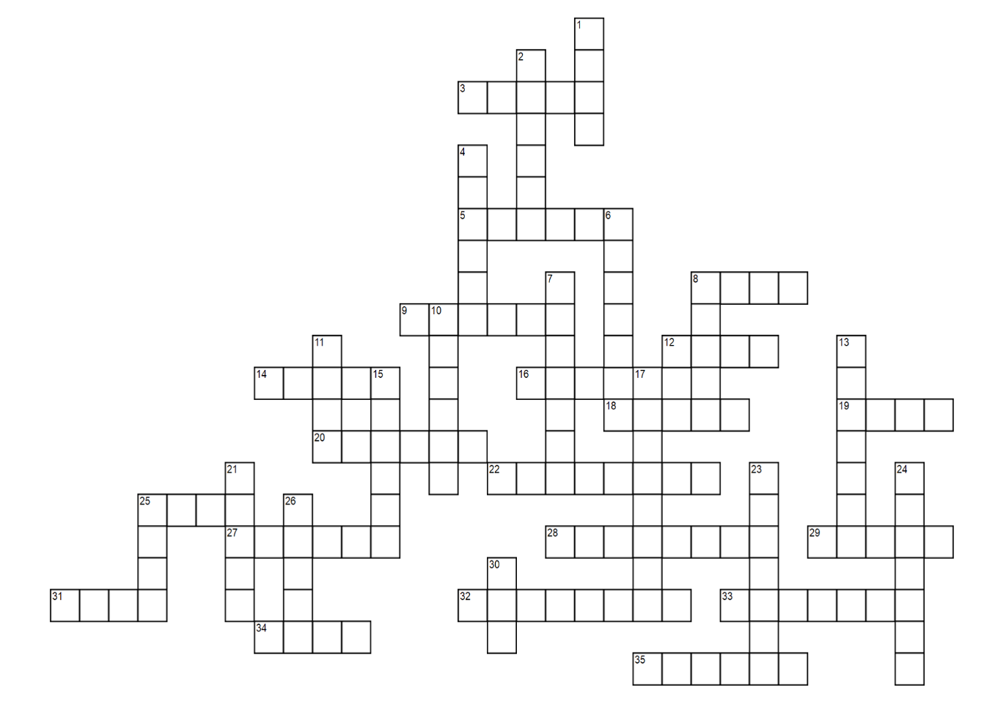

ACROSS | DOWN
3. This brother started the golf club at UF. Nickname: Ace | 1. This brother loves Howl’s Moving Castle. Nickname: Jiminy
5. This brother was born on Halloween. Nickname: Padowan | 2. This brother is from St. Pete. Nickname: Ghostrider
8. This brother’s favorite pokemon is Bulbasaur. Nickname: Mo Money | 4. This brother used to work at Beque-Holic. Nickname: Boba-Fett
9. This brother’s favorite flowers are sunflowers. Nickname: Oprah | 6. This brother is of Egyptian descent. Nickname: Sphinx
12. This brother drives a white Volkswagen Beetle. Nickname: Amethyst | 7. This brother was in a dance team in high school.
14. This brother owns a dog named “Oakley”. | 8. This brother is from Loxahatchee. Nickname: Skellington
16. This brother is the FPA/ACAP liason. Nickname: FDR | 10. This brother loves to snowboard. Nickname: Macaroon
18. This brother is from Tampa. Nickname: Forever Young | 11. This brother can hip hop dance. Nickname: Noh Face
19. This brother loves cheese. Nickname: Alfredo | 13. This brother played basketball in college. Nickname: Sporty Spice
20. This brother was a delegate for Dance Marathon. Nickname: Cani | 15. This brother is from Jacksonville just like their big. Nickname: Lohtus
22. This brother went to Notre Dame. Nickname: Southwest | 17. This brother is of Brazilian descent. Nickname: Dug
25. This brother’s mom is a member of the Delta chapter of PDC. Nickname: Miles | 21. This brother loves college football and watching the Gators play. Nickname: Carrots
27. This brother is from Land o’ Lakes. Nickname: Reesie Peeces | 23. This brother is from St. Petersburg. Nickname: Stove
28. This brother is very skilled at drawing. Nickname: Riff Raff | 24. This brother loves flaming hot Cheetos. Nickname: Blaze
29. This brother is from New Mexico. Nickname: Athena | 25. This brother was in the same team with Brothers Sturgill and Widell
31. This brother is an excellent chef. | 26. This brother is an intern at SinfoniaRx. Nickname: Moonbow
32. This brother is from Weston, FL. Nickname: KitCat | 30. This brother is from Michigan. Nickname: 8 Mile
33. This brother can make the best crab legs and sushi. Nickname: D.T. Heng
34. This brother’s family owns 30 acres of land. Nickname: Crash Bandiscoot
35. This brother is Brandon Flowers’ biggest fan. Nickname: Cakepop

